Murton Nature Reserve
Initial Proposal for Discussion at Community Council Meeting 24th February 2020
Lucie Sudbury.

As you all know I have been a member of the community council for approximately 18 months now and one of my main objectives is to enhance the local area and encourage outdoor facilities for all ages.
As such, and as a result of many meetings in relation to skate parks, pump tracks, locations, those for, those against etc, I have been considering alternative projects that could incorporate various elements of what has already been requested, make use of currently unused land and create a really beautiful natural outdoor space for use by the whole community.
At the moment a lot of the land on the opposite side to Murton Green itself, is unused Common land, but land with a lot of potential. With a bit of nurturing, a lot of community spirit and the approval of the council and the commoner’s association as well as a pot of money (amount as yet unknown) I think we could make a real attraction of it. One that would enhance the community, provide lovely walks, places to sit and reflect, wild flowers, plants and trees, pathways for dog walking and even a pump track of sorts, we could have wooden bridges over the stream, wooden boardwalks over the marshes and bark or gravel paths.
I envisage a little bird watching hut, information signs detailing the types of plants and foliage that can be found at different times of the year and also the insects, animals and birds that can be spotted, there may be scope for a small pond to be created and even possibly some rope bridges and tree houses, all made from natural, recyclable materials. The objective being to use what is naturally there and enhance it rather than to create something modern and overly man made.
This project could be used by local schools to enhance outdoor learning and could encourage trade to local business such as Murton Post Office, Northway Garage and Murton Farm to name just a few. Any local businesses or tradespeople who helped out either in person or by way of funding could receive recommendations and commendation both on our website and newsletter and on the community Facebook group.
In addition, we could run competitions with the local primary schools to help with the design of the facility and the Comp may be able to incorporate elements of the project into their local environment element of the Welsh baccalaureate. This would really encourage the community to be involved in the project and would create a sense of ownership, which would in turn discourage vandalism and antisocial behaviour within the facility.
We could invite the community to get involved as I am aware that we have numerous landscape gardeners, designers and project managers as well as plant and tree experts, children’s rights and out door play enthusiasts and funding and compliance experts all living locally, with a passion for their local community to evolve in an inclusive and environmentally friendly way
Attached are some photographs of other similar facilities and a map of the area proposed. I look forward to your views and invite comments.
Thanks,
Lucie
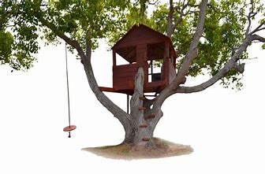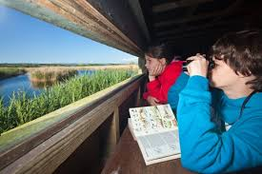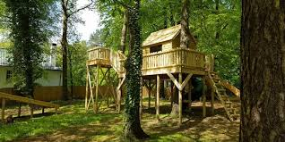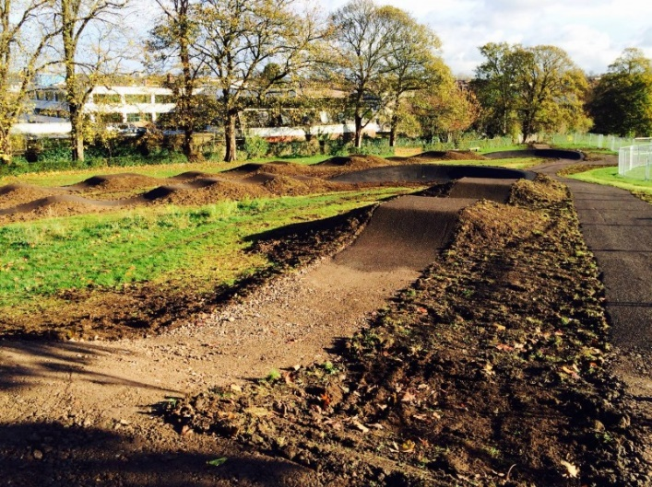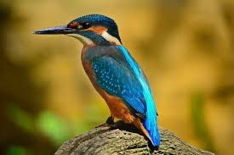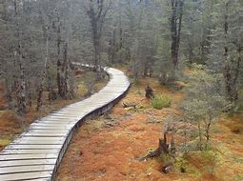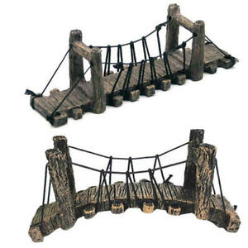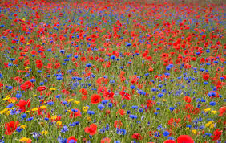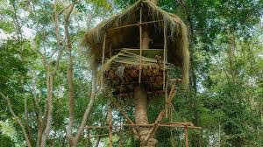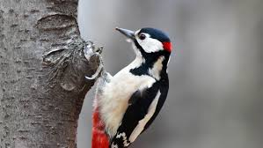
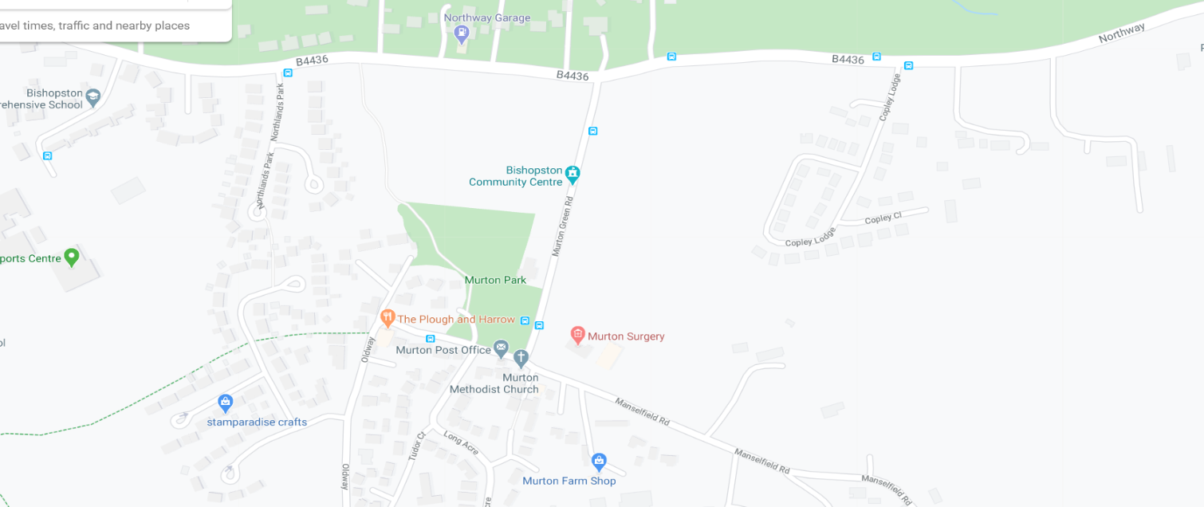
1 Nature Reserve

