Copley Regeneration Project
Nature reserve and accessible activities
Update 30.10.2023
Lucie Sudbury.

I have been a member of the community council for approximately five years, now and I first made this proposal back in 2018 when there was a lot of toing and froing around the possibility of a skate or pump track facility.
One of my main objectives as a community councillor is to enhance the local area and encourage outdoor facilities, recreational opportunities, safe spaces to meet and chat and fun things to do for all ages and abilities within our community.
As such, and as a result of many meetings in relation to skate parks, pump tracks, outdoor play, safe spaces, inclusive activities etc…as well as locations, those for, those against etc, I have been considering alternative projects that could incorporate various elements of what has already been requested, make use of currently barely used land and create a really beautiful natural outdoor space for use by the whole community.
At the moment a lot of the land on the opposite side to Murton Green itself, is unused Common land, but land with a lot of potential. With a bit of nurturing, a lot of community spirit and the approval of the council and the commoner’s association as well as a pot of money (amount as yet unknown) I think we could make a real attraction of it. One that would enhance the community, provide lovely walks, places to sit and reflect, wild flowers, plants and trees, pathways for dog walking and even a pump track of sorts, we could have wooden bridges over the stream, wooden boardwalks over the marshes and bark or gravel paths. All in keeping with the natural area but enhanced to be enjoyed by all.
I envisage bird watching huts, information signs detailing the types of plants and foliage that can be found at different times of the year and also the insects, animals and birds that can be spotted, there may be scope for a small pond to be created/ rejuvenated, and even possibly some rope bridges and tree houses, all made from natural, recyclable materials so that they can be easily maintained but also cause no permanent impact to the current surroundings. The objective being to use what is naturally there and enhance it rather than to create something modern and overly man made. The potential is endless, but maintenance and commitment to keeping it well tended and appealing will be one of the greatest tasks.
This project could be used by local schools to enhance outdoor learning and could encourage trade to local business such as Murton Post Office, Northway Garage and Murton Farm to name just a few. Any local businesses or tradespeople who helped out either in person or by way of funding could receive recommendations and commendation both on our website and newsletter and on the community Facebook group.
In addition, we could run competitions with the local schools to help with the design of the facility and the Comp may be able to incorporate elements of the project into their local environment element of the Welsh baccalaureate. This would really encourage the community to be involved in the project and would create a sense of ownership, which would in turn discourage vandalism and antisocial behaviour within the facility.
We could invite the community to get involved as I am aware that we have numerous experts including but not limited to landscape gardeners, designers and project managers as well as plant and tree experts, children’s rights, elderly carers, out door play workers and funding and compliance experts all living locally, with a passion for their local community to evolve in an inclusive and environmentally friendly way.

As a result of a 5 year period passing, due to covid and various other commitments, discussions have been ongoing with many people within the community who are interested in all aspects of this development, a feasibility study and pre -planning took place on the site for the pump track. That was refused and one of the reasons was that there is a recreational facility close by (Murton Green) and so that should be used – We are now all aware that there is a covenant stopping the green from being used and so we return our sights to the Copley woods sight but for the overall development as set out above rather than only a pump track/skatepark.
Attached are some photographs of other similar facilities and a map of the area proposed. I look forward to your views and invite comments via email to bishopstocommunitycouncil@outlook.com as well as suggestions on what could be done with the land even on a temporary or seasonal basis to see what works best and is most utilised by the community.

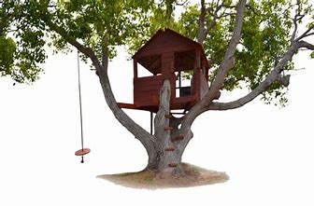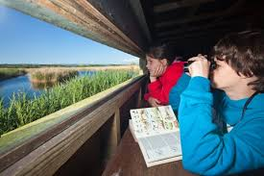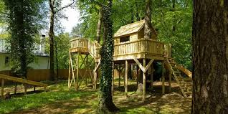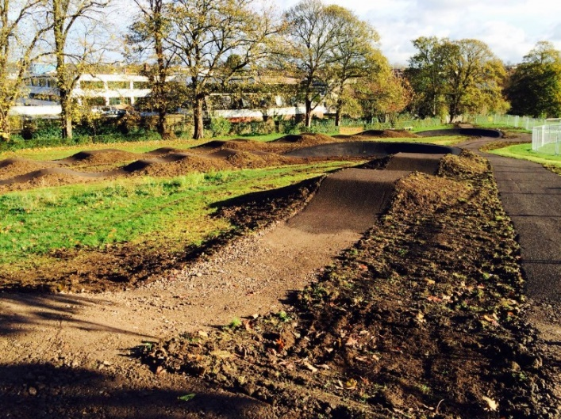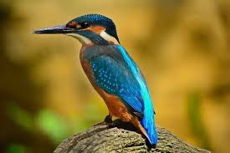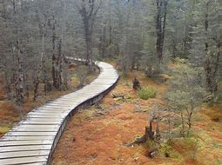
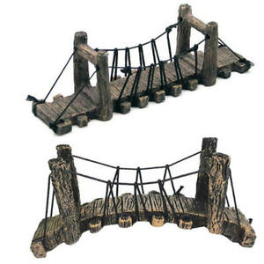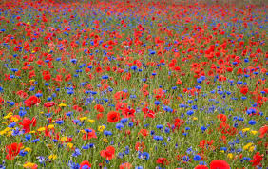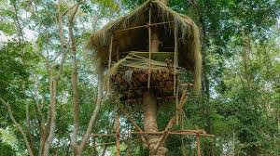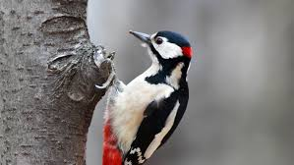
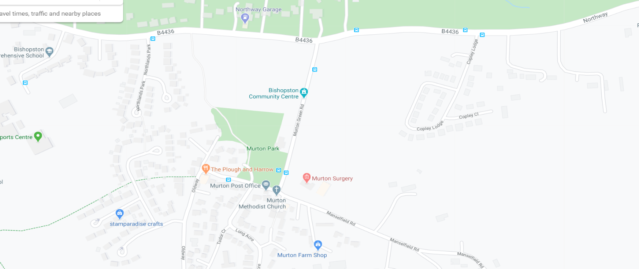
1 Nature Reserve

